ISSACK WAITHAKA
cs-sa07-24085

Broken Access Control
- This allows attackers to bypass authorisation allowing them to get sensitive data

Broken Access Control (IDOR Challenge)
- Insecure Direct Object Reference refers to an access control vulnerability where an attacker can access resources they shouldn’t.

Questions
1.
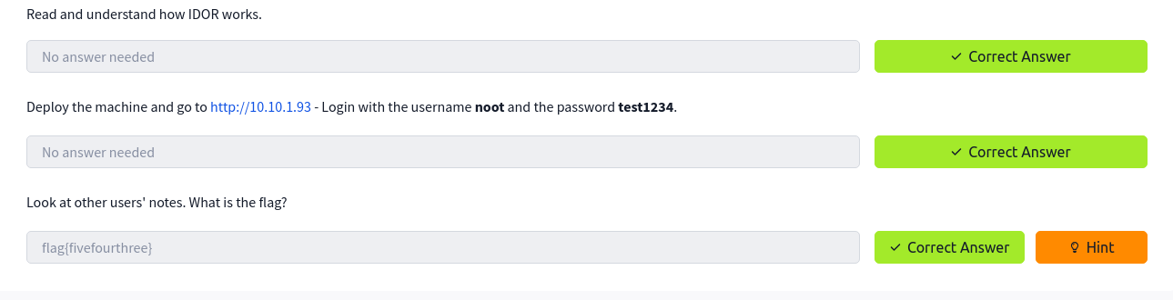
I was able able to login into the machine and adjusted the ID to 0 and got the flag
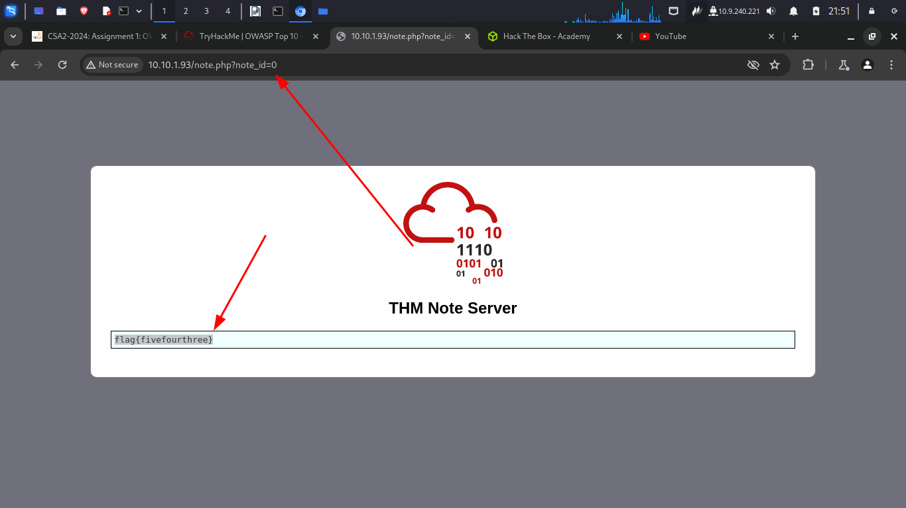

Cryptographic Failure
- This is any vulnerability that comes from misuse or lack of use of cryptographic algorithms

Questions
1.
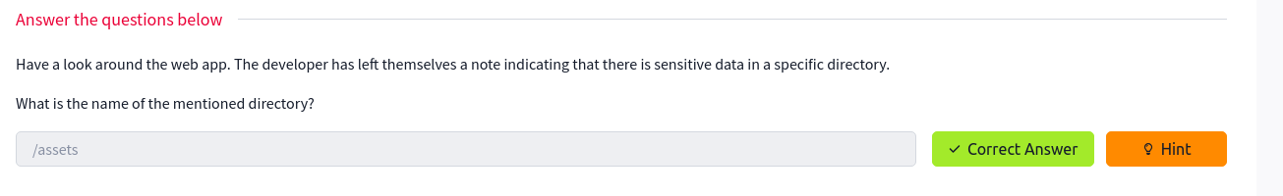
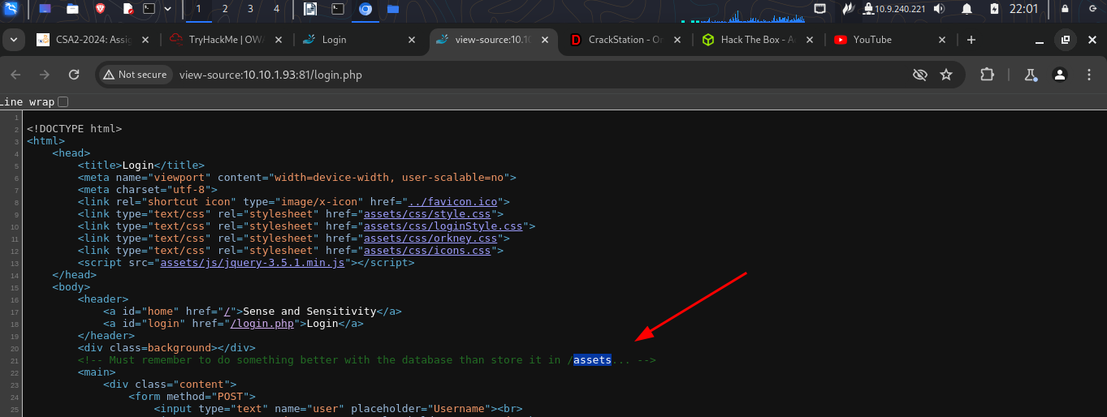
2.
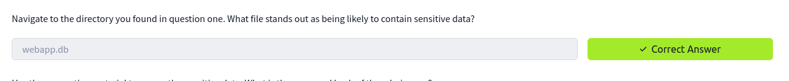
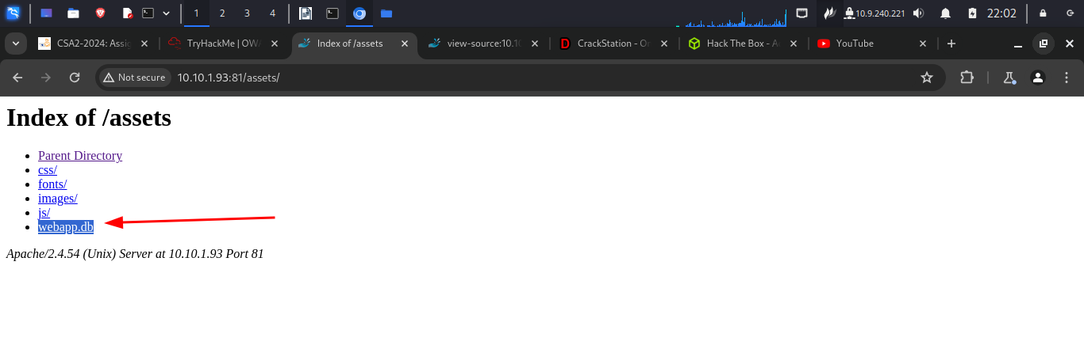

3.
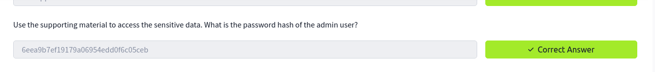
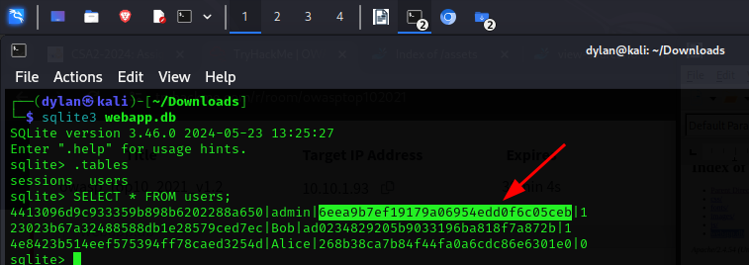
4.
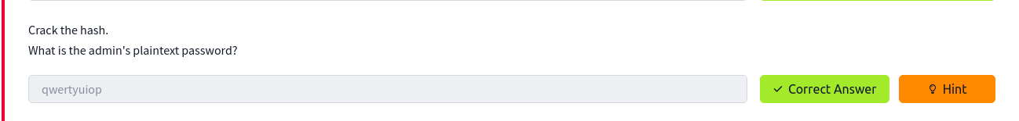
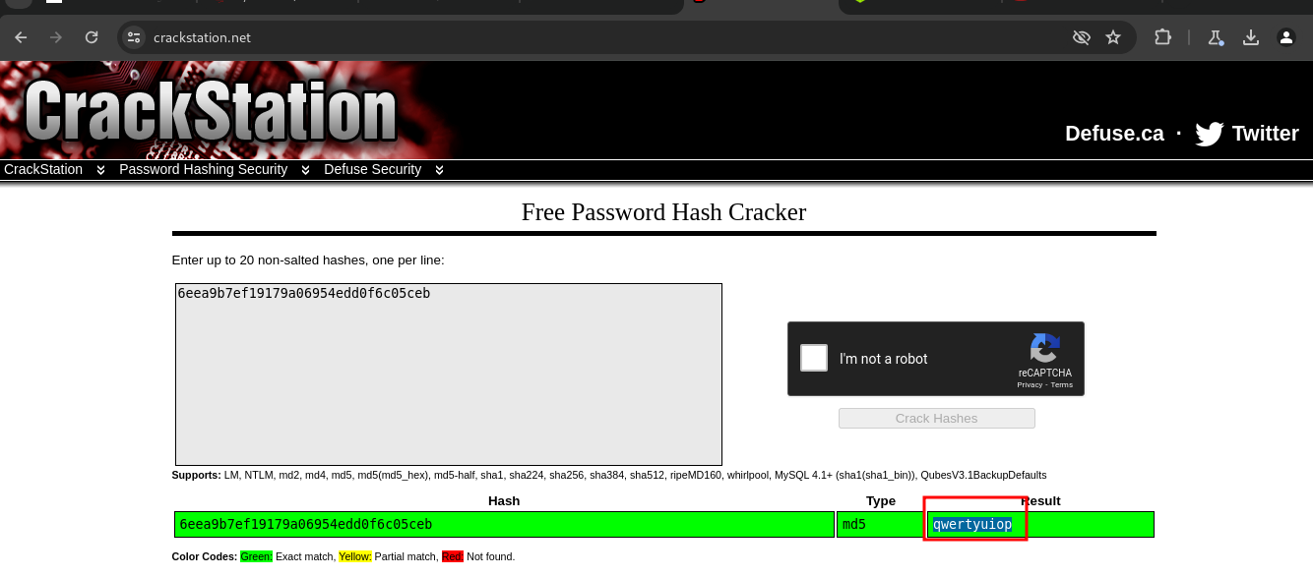

5.
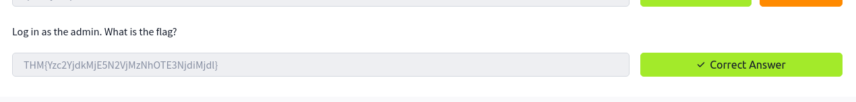
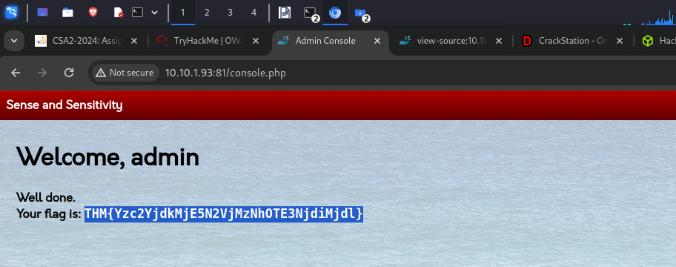

Injection
- This occurs when application interprets user-controlled input as commands or parameters
- SQL injection occurs when user-controlled input is passed to sql queries
- Command injection occurs when user input is passed to systems commands

Questions
1.
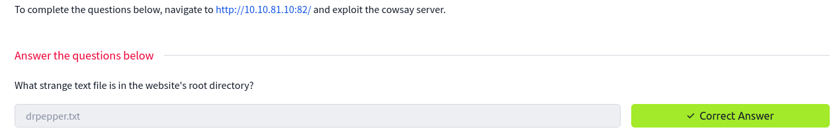
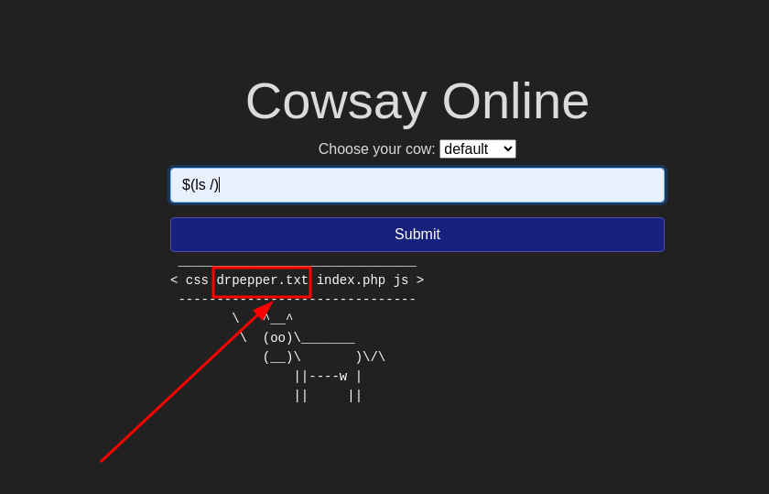
2.
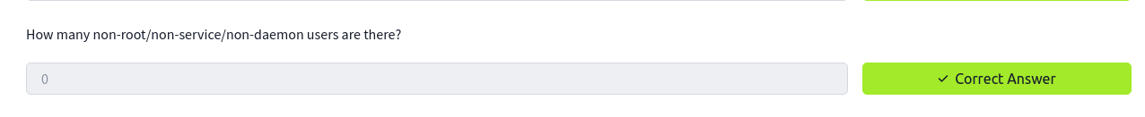
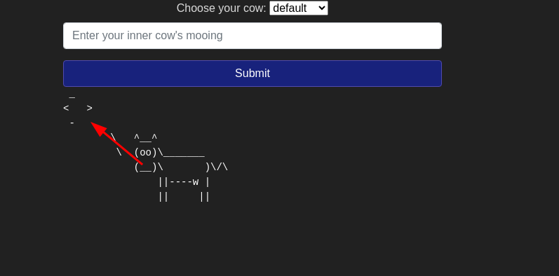

3.
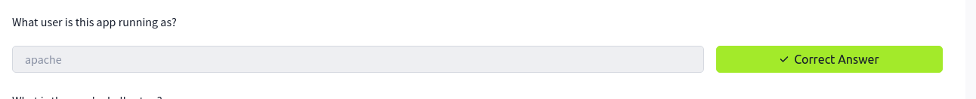

4
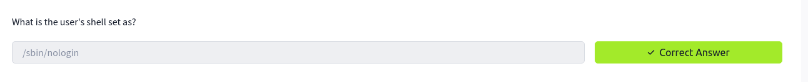
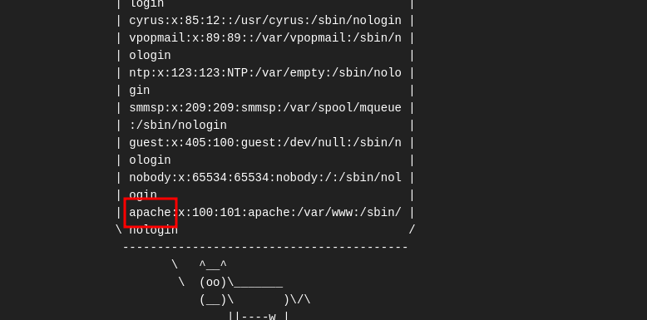
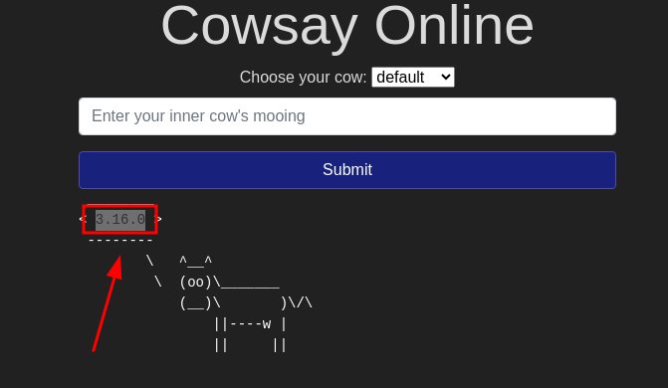

Insecure Design
- These are vulnerabilities from the application architecture
- It may also be included by developers when adding features in the code.

Questions
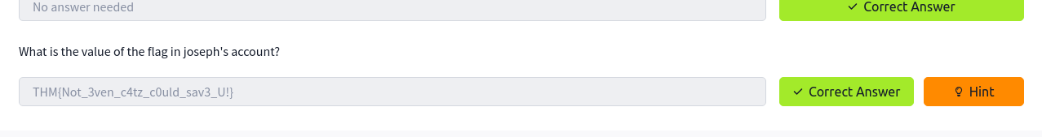
I navigated to the login page and chose the option forgot password. I then went to the security questions where I picked green as the favorite color of Joseph and that is how I was able to reset password
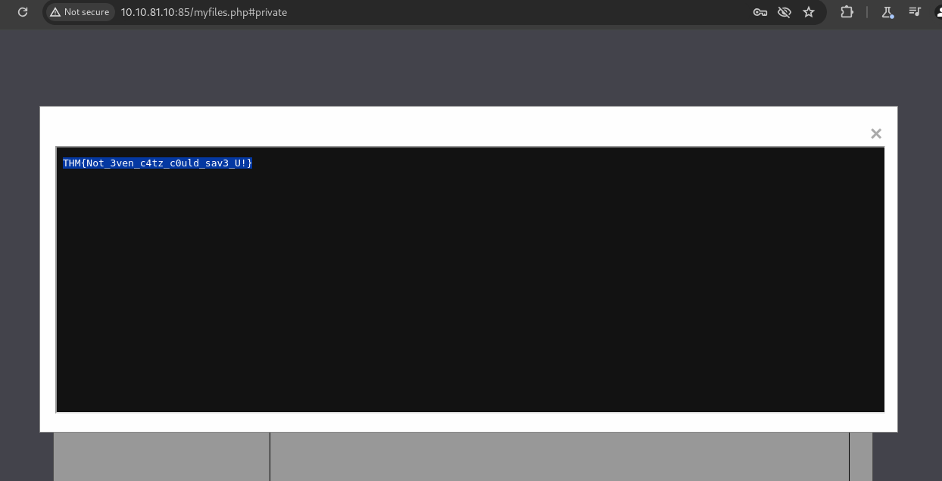

Security Misconfiguration
- This may occur due to many factors like poor configuration, having unnecessary features etc
Questions
1.
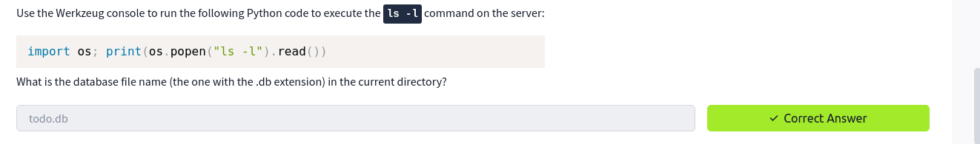
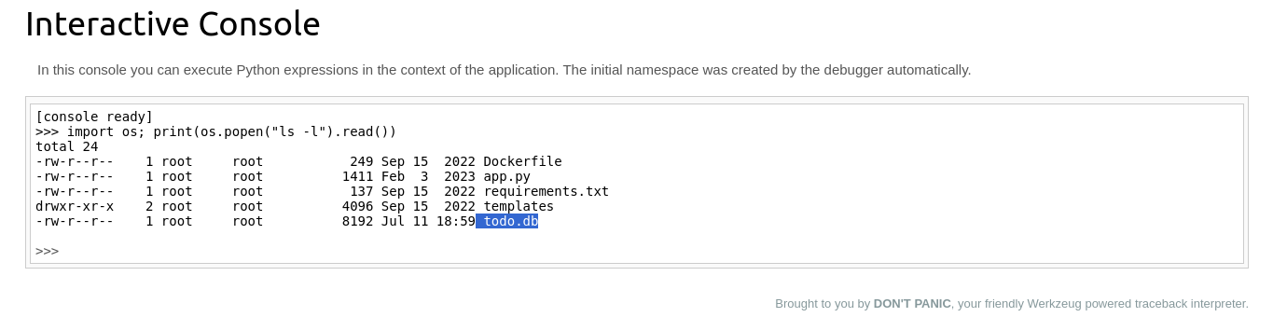
2.
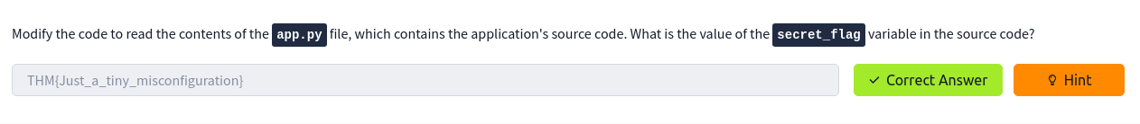
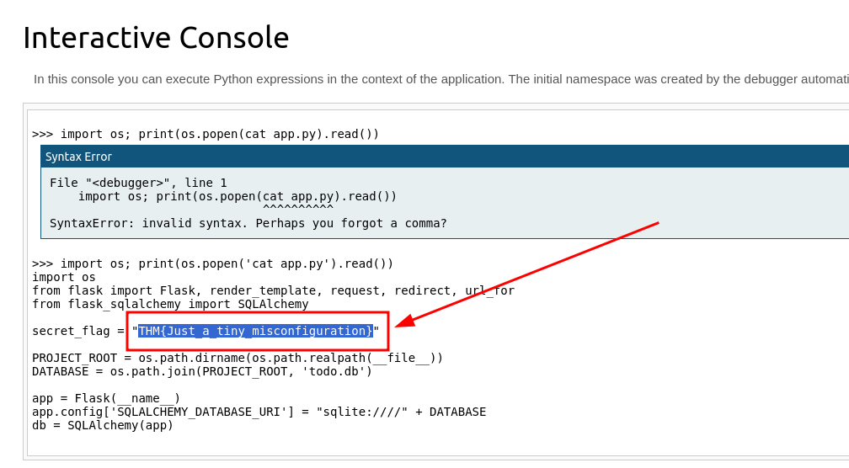

Vulnerable and Outdated components
- Outdated softwares are mostly vulnerable.

Questions
1.
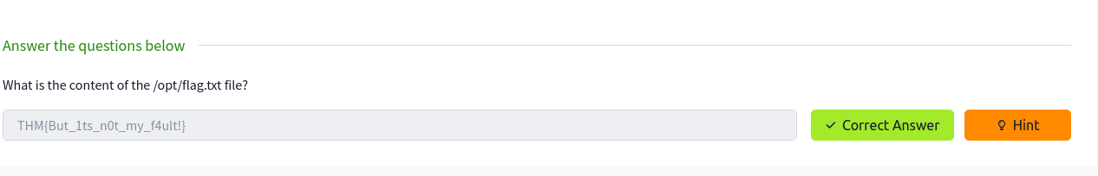
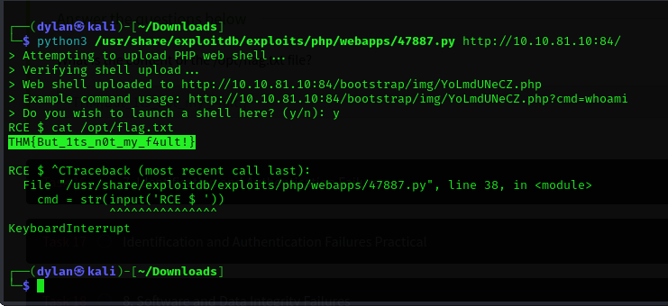

Identification and Authentication Failures
- Authentication verifies users identity before allowing them to access a web application

Questions
1.
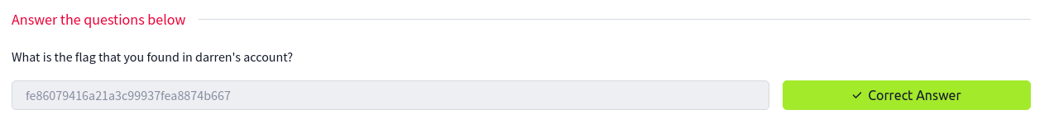
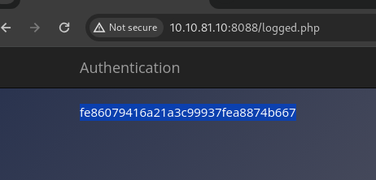

2.
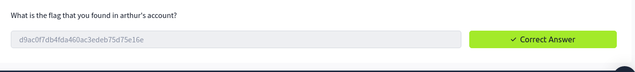
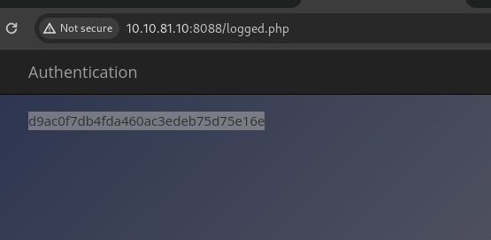

Software and data integrity
- Integrity is ensuring data is remains unmodified

Questions
1,
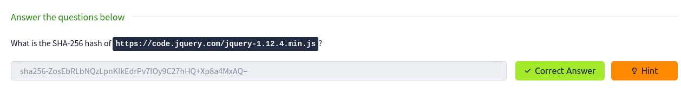
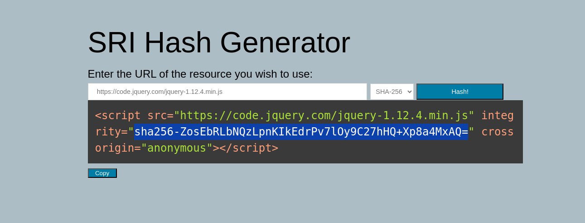
Data Integrity Failures
Questions
1.

2.
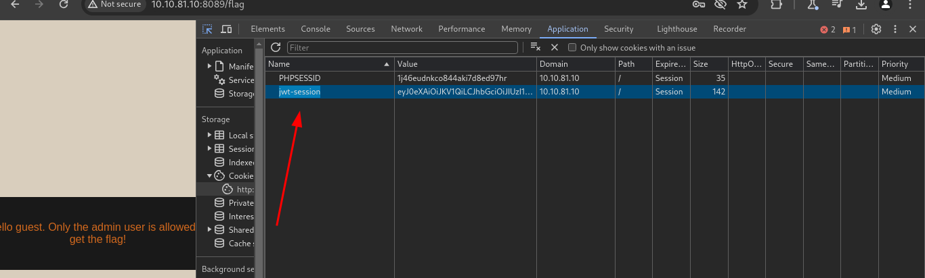
3
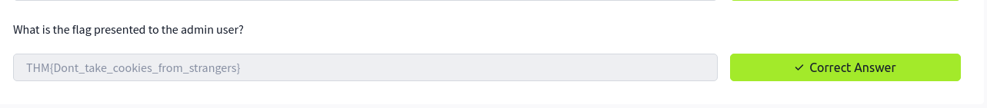
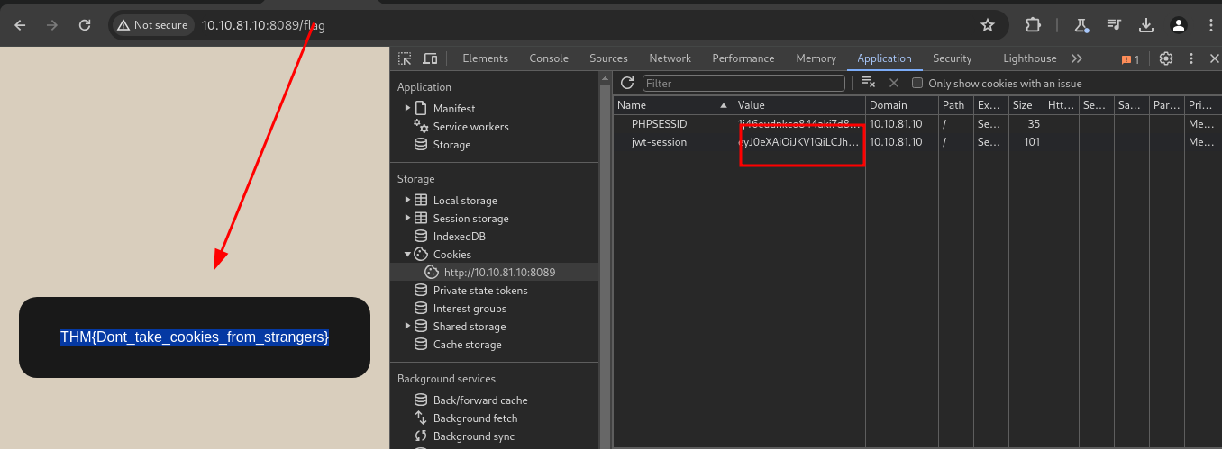

Security logging and monitoring Failures
- Every action performed should be logged making sure any malicious activities can be traced

Questions
1.
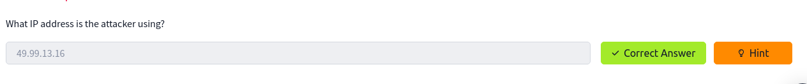
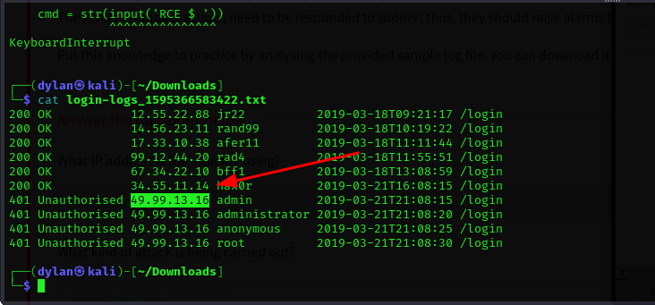
2.
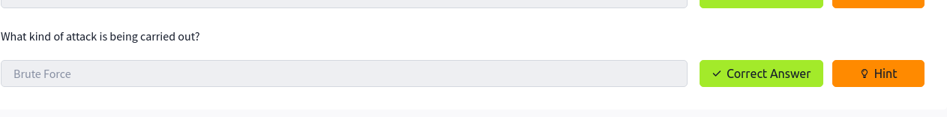

Server-side requeat Forgery
- This happens is a vulnerability that allows an attacker to cause the server side application to make requests to unintended location

Questions
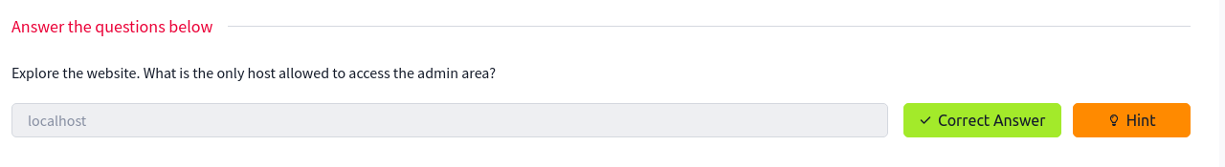
1.
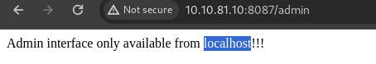

2.
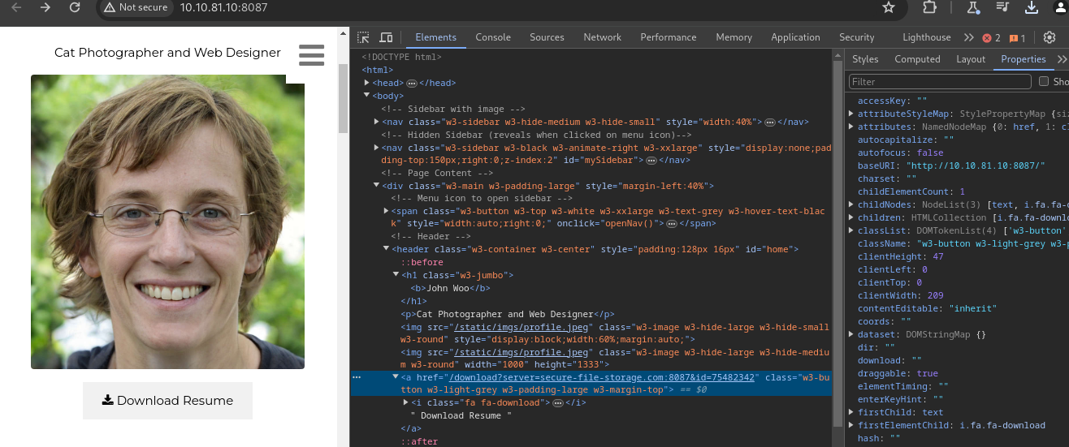



Conclusion
I was able to go through the various and most common Owasp top 10 vulnerabilities. It was a very interesting and informative room and I liked it. I can now use the skills I have learnt to practice more to improve my skills.

